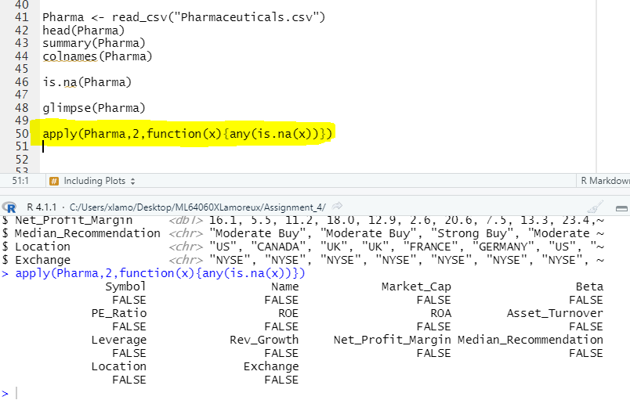

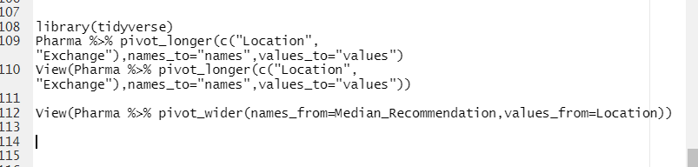

library(tidyverse)

Pharma %>% pivot_longer(c("Location", "Exchange"),names_to="names",values_to="values")

View(Pharma %>% pivot_longer(c("Location", "Exchange"),names_to="names",values_to="values"))

View(Pharma %>% pivot_wider(names_from=Median_Recommendation,values_from=Location))